**M**

**MOHAN BABU UNIVERSITY**

Sree Sainath Nagar, Tirupati 517 102

**SCHOOL OF COMPUTING**

**DEPARTMENT OF COMPUTER APPLICATIONS**

Certificate

This is to certify that the project report entitled “**WORD CLOUD GENERATOR”** is the bonafide work carried out and submitted by

**JILLELLAMUDI KAVYA**

**24102D020012**

in the Department of **Computer Applications, School of Computing** of **Mohan Babu University**, Tirupati in partial fulfillment of the requirements for the award of the degree of **Master/Bachelor of Computer Applications** during 2025-26.

**Guide Head of Dept.**

**Ms.Peddinti Neeraja Dr. M. Sowmya Vani**

**Assistant Professor, Associate Professor & Head,**

**Department of CA, Department of CA,**

**MBU,Tirupati. MBU,Tirupati.**

**Date:**

**DECLARATION**

I, **Jillellamudi Kavya** hereby declare that, the project entitled “**Word Cloud Generator**” developed by me at **MOHAN BABU UNIVERSITY**, Tirupati during the Academic year 2024-2025 and submitted to The Principal, MOHAN BABU UNIVERSITY for partial fulfilment for the award of Master/Bachelor of Computer Applications (MCA/BCA).

I also declare that, the project is resulted by my own effort and that it has not been copied from anyone and not been submitted by anybody in any of the University or Institution or Research Centre.

Place: Tirupathi

Date:

**Jillellamudi Kavya 24102D020012**

**ABSTRACT**

The **Word Cloud Generator** is a mini project developed to visually represent the most frequent words in a text dataset in an attractive and meaningful manner. In today’s digital world, massive amounts of textual data are generated from various sources such as social media, articles, blogs, reviews, and research papers. Understanding and analyzing this data manually can be time-consuming and inefficient. The Word Cloud Generator provides a simple yet effective way to summarize and visualize large volumes of text by highlighting the most commonly used words.

This project utilizes **Natural Language Processing (NLP)** techniques to clean and preprocess the input text by performing operations such as tokenization, stop-word removal, and normalization. After processing, the frequency of each unique word is calculated, and the results are displayed graphically in the form of a “word cloud,” where the importance or frequency of each word is indicated by its font size and color. The more frequently a word appears in the text, the larger and bolder it is shown in the cloud.

The system is developed using **Python programming language**, and it employs popular libraries like **WordCloud**, **matplotlib**, and **NLTK** for text processing and visualization. Users can input text manually or load it from a file, and the program automatically generates a word cloud image that can be saved or analyzed further.

The Word Cloud Generator can be effectively used in various fields, including **data analysis, sentiment analysis, marketing research, education, and social media monitoring**, to gain insights into textual trends and keyword prominence. The simplicity and efficiency of the system make it a valuable tool for beginners and researchers who wish to explore data visualization in natural language processing.

In conclusion, this mini project demonstrates how textual data can be transformed into a visually interpretable format, making information extraction easier and more engaging. It bridges the gap between raw data and human understanding through the power of visualization and serves as a foundation for more advanced text analysis applications.

**Table of contents**

**Title Page No**

Certificate……………………………………………………………………………….….i

Declaration…………………………………………………………...……………………ii

Abstract………………………………………………………………………...…………iii

1. Introduction…………………………....………………………………………………..01

1.1 Introduction……………………………………………………………………………01

1.2 Aim of the Project……………………………………………………………..………02

1.3 Project Domain………………………………………………………………………...03

1.4 Scope of the Project…………………………………………………………....………04

2. Literature Review……………………………………………………..…………………06

3. Problem Definition ………………………………………………………………..…….07

3.1 Existing System………………………………………………………………………...09

3.2 Hardware Requirements………………………………………………………………..10

3.3 Software Requirements……………………………………………………………… ..11

4. Proposed System……………………………………………………………………….. 12

4.1 Objectives ……………………………………………………………………………...13

4.2 Problem Formulation ………………………………………………………………….14

4.3 Methodology of Proposed System…………………………………………….……….17

5. Dataset Collection…………………………………………………………………….… 18

6. System Design……………………………………………………………………………22

6.1 High level Design Documentation………………………………………………………22

6.1.System Flow Chart……………………………………………………………………….23

**List of Figures**

1. Fig 6.1 Use case Diagram. …………………………………………………………....24
2. Fig 6.2 Class Diagram. ……………………………………………………….………25
3. Fig 6.3 Sequence Diagram. …………………………………………………………...26
4. Fig 6.4 Deployment Diagram. …………………………….………………….………27
5. Fig 6.5 Activity Diagram…………………………...…………………………………28
6. Fig 6.6 Object Diagram……………………………………………………………….29

7. Implementation…………………………………………………………………………30

7.1 Platform/ Technologies used ………………………….………………………………30

7.2 System Testing ………………………………………………………………………..31

7.2.1 Testing Strategies. ……………………………………………………...……………32

7.2.2 Test Cases……………………………………………………………………………33

7.3 Results…….…………………………………………………………………………...35

8. Conclusion………………………………………………………………………………36

8.1 Limitations…………………………………………………………………………….37

8.2 Future Work…………………………………………………………………...………38

9. References……………………………………………………………………………...39

Short Bio-data of the Student

**List of Tables**

1.Table 7.2.2.1:..s*ystem Test Cases for << Project modules>> …………………………*…33

**1.INTRODUCTION**

In the modern digital era, vast amounts of textual information are generated daily through social media posts, blogs, news articles, customer reviews, and online communication. Analyzing and interpreting such large volumes of unstructured text data can be a challenging task. To make this process more intuitive and visually engaging, text visualization tools like the **Word Cloud Generator** have become highly useful. A word cloud is a graphical representation of word frequency, where the size of each word indicates its importance or frequency in the given text. This form of visualization allows users to quickly identify the most significant and recurring terms within a dataset.

The **Word Cloud Generator** project aims to develop a simple yet powerful application that automatically processes textual data and generates a visual word cloud. The project leverages the **Python programming language** along with libraries such as **WordCloud**, **matplotlib**, and **NLTK** to perform text cleaning, preprocessing, and visualization. The system removes unnecessary words (stop words), counts the frequency of meaningful terms, and displays them in a visually appealing format. This not only enhances readability but also provides immediate insight into the key topics and patterns present in the text.

Such visualization tools play an important role in **data analysis, education, research, marketing, and sentiment analysis**, where identifying dominant keywords helps in better understanding of the content. The Word Cloud Generator also promotes interactive learning by helping students and researchers explore how natural language processing and data visualization work together to derive insights from raw textual data.

In this project, users can input text directly or load it from an external file, and the system automatically generates a colorful, dynamic word cloud. The simplicity of its design makes it user-friendly for beginners, while its functionality provides valuable learning experience in text analytics and Python programming.

Overall, the **Word Cloud Generator** project demonstrates how data visualization techniques can transform plain text into an informative and engaging visual format. It reflects the importance of combining computational power with creativity to make complex data easier to understand and analyze.

## ****1.1 Introduction:****

In the age of information technology, a massive amount of text data is generated daily through digital platforms such as social media, blogs, news websites, research papers, and customer reviews. Extracting meaningful insights from this large volume of unstructured text is one of the key challenges in data analysis. Understanding which words or concepts appear most frequently in a dataset can help researchers, analysts, and organizations identify trends, opinions, and key themes quickly.

The **Word Cloud Generator** is a simple yet powerful visualization tool designed to display the most frequent words in a given text in an aesthetically appealing way. In a word cloud, each word’s size and prominence are directly proportional to its frequency or importance within the dataset. This visual approach transforms raw textual data into a clear and engaging format that allows users to grasp the essence of the content at a glance.

This project utilizes the **Python programming language**, which is known for its readability, simplicity, and extensive support for data analysis. Python libraries such as **WordCloud**, **matplotlib**, and **NLTK (Natural Language Toolkit)** are used to process text, remove stop words, perform tokenization, and generate a graphical word cloud. The output effectively summarizes the textual information, making it easier to interpret the main topics, emotions, and patterns hidden in the data.

The **Word Cloud Generator** serves as an excellent example of how text mining and data visualization can be combined to simplify data understanding. It can be applied to a wide variety of fields such as education, research, marketing, social media analysis, and content creation. For instance, educators can visualize important keywords in study materials, while companies can use word clouds to identify popular terms in customer feedback or reviews.

This project not only demonstrates the power of data visualization but also enhances the user’s understanding of **Natural Language Processing (NLP)** techniques. It provides hands-on experience in implementing algorithms that transform raw text into structured insights and visually appealing outputs. Additionally, the project encourages creativity in presentation by allowing customization in color, shape, and font of the generated word clouds.

In conclusion, the **Word Cloud Generator** is a practical and educational project that showcases how simple programming and visualization tools can make complex data easier to interpret. It bridges the gap between text analytics and visual storytelling, enabling users to transform information into knowledge effectively.

## ****1.2 Aim of the Project:****

The main aim of the **Word Cloud Generator** project is to design and develop an application that effectively visualizes textual data by highlighting the frequency and importance of words in a creative and meaningful way. The project seeks to transform unstructured text into a structured visual format that is both informative and visually appealing, allowing users to easily interpret and analyze large volumes of textual information.

The concept behind this project is to make text analysis simple, interactive, and insightful by using **data visualization techniques**. Instead of reading lengthy paragraphs or datasets, users can instantly identify the most important words by viewing the generated word cloud. This not only saves time but also enhances comprehension, making it a valuable tool for data analysis, academic research, marketing, and education.

The **Word Cloud Generator** project also aims to introduce students and beginners to the fundamentals of **Natural Language Processing (NLP)** and **Python-based visualization**. Through this project, users learn how to preprocess text by removing stop words, performing tokenization, and counting word frequencies. The project further demonstrates how libraries like **WordCloud**, **matplotlib**, and **NLTK** can be integrated to produce meaningful visual outputs from raw text data.

In addition to its analytical purpose, the project encourages creativity by allowing customization of the word cloud’s appearance—such as color themes, shapes, font styles, and background settings—making the visualization not only informative but also visually engaging.

**Specific Objectives of the Project:**

* To provide a simple and interactive tool for analyzing and understanding large text datasets.
* To demonstrate the use of Natural Language Processing (NLP) techniques in cleaning, tokenizing, and preprocessing text data.
* To generate a visual representation of textual information that highlights the most frequently occurring and significant words.
* To help students, researchers, and analysts quickly identify key topics, ideas, and trends within a dataset.
* To promote learning and practical application of **Python programming** and its visualization libraries such as WordCloud and matplotlib.
* To enhance analytical thinking and creativity by allowing users to modify and customize the design of word clouds.
* To serve as a foundation for advanced text analysis projects like sentiment analysis, topic modeling, and text summarization.

****1.3 Project Domain:****

This project belongs to the domain of **Data Visualization** and **Natural Language Processing (NLP)** — two powerful and rapidly growing areas in the field of computer science and artificial intelligence. Together, these domains enable the transformation of complex and unstructured text data into meaningful, interpretable, and visually engaging representations

****Data Visualization:****

### **Data Visualization** is the graphical representation of data and information using visual elements such as charts, graphs, maps, and clouds. The main goal of data visualization is to make complex data easier to understand and analyze by presenting it in an intuitive and interactive format. In this project, visualization plays a central role, as the word cloud acts as a **visual summary** of text data, showing which words occur most frequently. Larger and bolder words represent higher frequency, providing an immediate understanding of dominant terms and patterns without requiring statistical analysis.

Data visualization helps bridge the gap between **raw data** and **human understanding**, enabling decision-making, storytelling, and trend recognition. In the context of this project, visualization converts text-based datasets into a **colorful and informative word cloud**, making it both educational and visually appealing.

### ****Natural Language Processing (NLP):****

**Natural Language Processing (NLP)** is a branch of **Artificial Intelligence (AI)** that deals with the interaction between computers and human languages. It focuses on enabling machines to read, understand, and process textual or spoken data. NLP combines computational linguistics with statistical, machine learning, and deep learning models to perform tasks such as sentiment analysis, language translation, text classification, and information retrieval.

In the **Word Cloud Generator**, NLP techniques are applied to preprocess the text — including tasks like **tokenization**, **stop-word removal**, and **word frequency analysis**. These preprocessing steps help clean the text and extract meaningful terms that accurately represent the core content. The project demonstrates how basic NLP methods can be implemented effectively using Python’s **NLTK (Natural Language Toolkit)** library to prepare data for visualization.

### ****Integration of Domains:****

The **Word Cloud Generator** project serves as an intersection of these two domains. NLP techniques prepare and clean the text data, while data visualization techniques transform that processed data into a visual format that users can easily interpret. This integration highlights the importance of combining **analytical processing** with **visual storytelling** to enhance understanding and communication of information.

****1.4 Scope of the Project:****

The scope of the **Word Cloud Generator** project is broad, practical, and adaptable to various real-world scenarios where textual data analysis and visualization are required. In today’s digital age, enormous amounts of textual data are generated every second from social media platforms, blogs, customer feedback forms, emails, and online reviews. Extracting insights from such large volumes of unstructured text can be challenging without the aid of visualization tools. The Word Cloud Generator provides a simple yet powerful solution by transforming complex text data into an easy-to-understand graphical format, allowing users to quickly identify the most frequent and meaningful words in a dataset.

This project demonstrates how text processing and visualization techniques can be applied to summarize information effectively, making it useful across multiple domains including **education, business, research, and data analytics**. Its applications go beyond basic visualization, offering opportunities for advanced development and integration with other technologies.

### ****Practical Applications****

### ****Data Analytics:**** Data analysts can use the Word Cloud Generator to analyze large text datasets such as product reviews, survey responses, or social media posts. By identifying the most common words or themes, analysts can uncover trends, customer opinions, and patterns that aid in decision-making.

### ****Education and Research:**** Teachers, students, and researchers can utilize the tool to visualize key concepts from academic papers, lecture notes, or project reports. This helps in identifying important topics and keywords quickly, making learning more engaging and interactive. Word clouds can also be used in presentations or publications to summarize research findings visually.

### ****Business and Marketing:**** In the corporate world, businesses and marketing teams can analyze customer feedback, online reviews, and social media comments to understand brand perception and consumer sentiment. Word clouds can highlight commonly discussed topics, helping organizations improve their services, campaigns, or communication strategies.

**Media and Communication:**  
Journalists, bloggers, and content creators can use the Word Cloud Generator to identify trending keywords or topics from news articles, online discussions, or social media data. This assists in content planning and audience engagement.

**2.Literature Review**

The **Literature Review** provides an overview of existing research, studies, and tools related to text analysis, data visualization, and Natural Language Processing (NLP). It helps to understand the background, evolution, and advancements in the techniques used for generating word clouds and visualizing textual data. Reviewing past work also identifies the limitations of existing systems and highlights how the **Word Cloud Generator** project provides an improved or simplified solution.

****Background Study:****

With the rise of digital communication, massive amounts of textual data are produced daily through blogs, reviews, articles, and social media platforms. Understanding this data is crucial for organizations, researchers, and educators. Traditional text analysis methods, such as manual reading and keyword counting, are time-consuming and ineffective for large datasets.

The concept of a **word cloud** (also called a “tag cloud”) emerged as a visual method to represent word frequency within text. Words are displayed in varying sizes based on their occurrence — larger words appear more frequently in the dataset. Word clouds gained popularity as they provide a quick and interactive way to summarize content visually.

In the field of **Natural Language Processing (NLP)**, text preprocessing steps such as tokenization, stop-word removal, stemming, and lemmatization play a vital role in cleaning and structuring data before visualization. Combining these techniques with data visualization tools like **WordCloud**, **matplotlib**, and **NLTK** in Python has made automated word cloud generation both simple and efficient.

**Related Works:**

Several research works and projects have been conducted in the area of text visualization and NLP-based data representation:

* **Feinberg (2009)** introduced the concept of word clouds as a visualization tool in social media and online platforms, which helped users quickly identify trends and key topics in user-generated content.
* **Heimerl et al. (2014)** presented “Word Cloud Explorer,” a system that integrated interactive exploration with visualization to improve the analytical capabilities of traditional word clouds.
* **Börner et al. (2010)** emphasized the importance of data visualization in knowledge discovery, explaining how visual summaries can improve human understanding of complex datasets.
* **Viegas and Wattenberg (2008)** explored the use of tag clouds for information summarization and navigation, particularly in online communities and blogs.
* **Recent studies (2018–2023)** in the fields of data science and NLP have focused on improving word cloud accuracy using contextual embeddings and sentiment-based coloring, enabling more meaningful visualizations beyond mere frequency counting.

**3.Problem Definition**

In today’s digital era, an enormous amount of textual data is generated every second through various sources such as social media platforms, online reviews, blogs, news articles, and research publications. This unstructured textual data contains valuable insights, but analyzing it manually is a time-consuming and inefficient process. Identifying key words, dominant themes, and frequently discussed topics in large text datasets can be challenging without automated tools.

Traditional methods of text analysis involve reading through documents, counting word occurrences manually, or using complex analytical software that requires advanced technical skills. These methods not only consume significant time and effort but also make it difficult for non-technical users to extract useful information from the data. There is a need for a simple, efficient, and visually appealing solution that can help users quickly understand the core content and key terms present in textual data.

The **Word Cloud Generator** project aims to address this problem by providing an automated approach to **analyze and visualize textual data**. By using **Natural Language Processing (NLP)** techniques such as tokenization, stop-word removal, and word frequency analysis, the system processes the given text and generates a **word cloud** — a graphical representation where the size of each word reflects its frequency or importance. This allows users to instantly identify the most significant words in the dataset without deep technical knowledge.

The project eliminates the need for complex data analysis tools and makes text understanding more accessible. It also demonstrates the integration of NLP and data visualization concepts, showing how simple algorithms can turn raw text into meaningful visual insights. The system is designed to be lightweight, user-friendly, and customizable, allowing users to input any text and generate a word cloud in just a few steps.

****Problem Statement:****

There is a lack of simple and interactive tools for analyzing unstructured textual data and identifying key terms efficiently. Users often struggle to extract important information from large text datasets due to the absence of visualization-based solutions. Therefore, there is a need to develop a **Word Cloud Generator** that:

* Automatically processes and cleans textual data using NLP techniques.
* Identifies and displays the most frequent and meaningful words.
* Provides an easy-to-understand visual representation of data through a word cloud.
* Offers customization features such as color, shape, and font to enhance presentation.
* Serves as an educational tool for students and researchers to learn text analysis and visualization.

### ****3.1 Existing System:****

In the existing scenario, textual data analysis is often performed using manual methods or through complex analytical software systems. Traditional approaches require users to read large amounts of text, identify important words manually, and interpret data patterns based on observation. This process is **tedious, time-consuming, and prone to human errors**, especially when dealing with massive text datasets such as articles, research papers, blogs, reviews, and social media posts.

While some online tools and platforms are available to generate word clouds, they often have **functional and accessibility limitations**. Many of these tools require **continuous internet connectivity**, depend on **subscription-based services**, or restrict features like customization, data size, and output quality. Moreover, online tools may **lack data privacy**, since users must upload text to third-party servers — which can be a concern when dealing with confidential or sensitive data.

Furthermore, these existing tools generally focus only on **visual generation** without including important preprocessing steps like **tokenization**, **stop-word removal**, or **lemmatization** — which are essential for accurate word frequency analysis. As a result, common and irrelevant words may dominate the visualization, reducing its analytical value.

In academic or research environments, users often rely on **complex text mining or NLP tools** that require programming knowledge and advanced computational resources. However, these tools can be overwhelming for beginners and non-technical users who simply need a quick, visual summary of textual data.

#### ****Limitations of the Existing System:****

* Requires **manual effort** and **time** for text cleaning and keyword identification.
* Many existing tools need an **active internet connection** to function.
* **Limited customization** options (fonts, shapes, colors, and layouts).
* **Restricted file size support** for large documents or datasets.
* Lack of **integration** with NLP or analytical modules for further insights.
* **Data privacy issues** when uploading sensitive text online.
* Commercial software with full features is often **costly and inaccessible** to students.
* Hence, the existing systems fail to provide a **simple, offline, customizable, and cost-effective** tool that bridges the gap between **data analysis and visualization** for everyday users.

## ****3.2 Hardware Requirements:****

The **Word Cloud Generator** is a lightweight desktop application that does not require high-end computer resources. It can efficiently run on any standard laptop or personal computer with minimal configuration. However, to ensure smooth performance and faster processing of large text files, certain hardware requirements are recommended.

| **Component** | **Minimum Requirement** | **Recommended Requirement** |
| --- | --- | --- |
| **Processor (CPU)** | Intel Core i3 (2.0 GHz) or equivalent | Intel Core i5 / AMD Ryzen 5 or higher |
| **RAM** | 4 GB | 8 GB or higher |
| **Hard Disk Space** | 250 MB of free storage | 1 GB free for saving multiple outputs |
| **Display** | 1024 × 768 pixels resolution | 1366 × 768 pixels or higher |
| **Keyboard** | Standard QWERTY keyboard | Multimedia keyboard (optional) |
| **Mouse** | Optical USB / Wireless mouse | Any high-precision mouse |
| **Operating System** | Windows 7/8/10/11, Linux, or macOS | Windows 10/11 or Ubuntu 20.04+ |

### ****Explanation:****

### The **processor and RAM** ensure smooth execution of Python libraries like WordCloud and matplotlib without lag.

### A **good display resolution** helps render high-quality word clouds.

### The system requires **minimal disk space** to store generated images and text files.

### As the project runs offline, no network connection or server hardware is needed.

### The hardware requirements make the project accessible to students and researchers using standard systems in labs or at home.

**3.3 Software Requirements:**

The **Word Cloud Generator** mini project is developed using open-source software tools that are easy to install, simple to use, and suitable for students learning Natural Language Processing (NLP) and Data Visualization.  
Each software component plays an important role in ensuring that the project runs efficiently and produces accurate, visually appealing results.

Below is the detailed description of the software required and how it is used in the project.

****1.Operating System:****

**Requirement:**  
Windows 7/8/10/11, Linux (Ubuntu 20.04+), or macOS

**Use in the Project:**  
The operating system provides the basic platform on which Python and its libraries are executed.

* It manages file handling for input and output text files.
* It runs the Python interpreter and displays graphical outputs such as the generated word cloud.
* Any OS that supports Python can be used, making the project portable and easy to run on different machines.

****2. Programming Language: Python****

**Requirement:**  
Python 3.8 or higher

**Use in the Project:**  
Python is the main programming language used to develop this mini project. It is simple, flexible, and powerful for text analysis and visualization tasks.  
In this project, Python is used to:

* Write the main code for reading, cleaning, and analyzing text data.
* Generate the word cloud image using the **WordCloud** library.
* Display the final output graphically using **matplotlib**.
* Perform text preprocessing using **NLP techniques** through libraries like **NLTK**.
* Python is chosen because it is beginner-friendly and widely used in Artificial Intelligence, Machine Learning, and Data Science applications.

**4.Proposed System**

The **Proposed System** of the Word Cloud Generator project is designed to provide a simple, efficient, and offline solution for visualizing text data. It addresses the limitations of existing online tools by offering a user-friendly platform that converts textual information into an attractive and meaningful graphical representation, known as a word cloud.

The system processes raw text using **Natural Language Processing (NLP)** techniques, such as text cleaning, tokenization, and stop-word removal, and then applies **Data Visualization** techniques to generate a word cloud. Words that appear more frequently in the dataset are displayed in larger, bolder fonts, giving users an instant understanding of the most significant terms in their data.

This project makes use of **Python** and its powerful libraries such as **WordCloud**, **matplotlib**, and **NLTK**, which together handle text processing and visualization efficiently. The system can run completely offline, making it ideal for students, researchers, and professionals who want to analyze text without relying on the internet or expensive software tools.

**Objectives of the Proposed System:**

The main objectives of this system are:

* To develop a **Python-based mini project** that generates a word cloud from textual input.
* To demonstrate **NLP techniques** such as tokenization and stop-word removal for text preprocessing.
* To create a **visual representation** that emphasizes word frequency and importance.
* To provide a **simple, offline, and cost-free** tool for text analysis and learning purposes.
* To enhance users’ understanding of how text data can be transformed into meaningful visual insights.

**Features of the Proposed System**

**Offline Functionality:** Can be used without an internet connection.

**Simple User Interface:** Easy to run and use even for beginners.

**Text Cleaning:** Removes special characters, punctuation, and stop words.

**Word Frequency Calculation:** Automatically identifies and ranks words by frequency.

**Customizable Output:** Supports different fonts, colors, and background options.

**Visualization & Export:** Displays the final word cloud and allows saving as an image (.pngor .jpg).

## ****4.1 Objectives:****

The main objective of the **Word Cloud Generator** project is to develop an application that can visually represent the frequency of words within a given text, making it easier to understand the most important or commonly used terms. This project combines **Natural Language Processing (NLP)** techniques and **Data Visualization** methods to transform unstructured text data into a meaningful and attractive word cloud image.

The specific objectives of the project are as follows:

**1.To design and develop a simple text visualization tool:**  
Create a user-friendly and offline application that generates word clouds efficiently from any text file or input text.

**2.To implement Natural Language Processing techniques:**  
Apply NLP methods such as tokenization, stop-word removal, and text cleaning to process and prepare raw text data for analysis.

**3.To identify and analyze word frequency:**  
Calculate how often each word appears in the dataset and visually represent the importance of words based on their frequency.

**4.**To develop a Python-based educational project:****  
Use Python and open-source libraries such as WordCloud, matplotlib, and NLTK to demonstrate practical programming and data visualization skills.

**5.**To enhance understanding of textual data analysis:****  
Help users—especially students and researchers—gain insights into key topics, themes, and patterns from large text collections through visualization.

****6.To provide offline accessibility:****  
Enable users to generate word clouds without needing an internet connection, making it suitable for academic and offline environments.

**7.**To encourage learning and creativity:****  
Allow customization of font styles, colors, shapes, and background themes, giving users creative control over their visualization output.

## ****4.2 Problem Formulation:****

In the current digital era, a massive amount of textual information is being produced daily through sources like social media, online reviews, news articles, research papers, and blogs. Extracting meaningful insights from such unstructured text is a major challenge in the field of data analysis and natural language processing. Traditional text analysis methods often require complex tools or manual interpretation, which can be time-consuming, costly, and difficult for beginners to use.

The problem arises when users, especially students and researchers, need a **simple and efficient tool** to understand the key concepts or most frequently used words within a large text document. Existing online word cloud tools have several limitations, such as the need for an internet connection, lack of customization options, and restrictions on data size. Moreover, many professional text analytics tools are expensive or require advanced technical knowledge.

Therefore, there is a need to develop an **offline, user-friendly, and open-source system** that can automatically process textual data, clean it, and visualize word frequency in an appealing and informative way. The **Word Cloud Generator** aims to solve this problem by providing an easy-to-use platform that helps users quickly identify significant words and patterns from any text input.

**Problem Statement:**

To design and develop a **Python-based Word Cloud Generator** that can:

* Take text input from a user or file.
* Preprocess and clean the text by removing punctuation, symbols, and stop words.
* Calculate the frequency of each word in the text.
* Generate a visually appealing word cloud image, where word size represents its frequency.
* Allow offline usage with customizable options like font, color, and layout.

**Key Challenges:**

* Handling large and unstructured text data effectively.
* Removing unnecessary or common words (stop words) without losing key information.
* Accurately calculating word frequency for meaningful visualization.
* Providing a clear and customizable visual output for better interpretation.
* Ensuring the system remains lightweight, offline, and user-friendly.

**Proposed Solution:**

The **Word Cloud Generator** project provides a practical solution by combining **Natural Language Processing (NLP)** and **Data Visualization** techniques.  
It preprocesses the input text, applies frequency analysis, and generates a colorful visual representation of the most important words using Python libraries like WordCloud, matplotlib, and NLTK.  
This tool not only simplifies text analysis but also enhances user understanding by turning textual data into an informative and attractive image.

## ****4.3 Methodology of Proposed System:****

The **methodology** of the **Word Cloud Generator** defines the step-by-step approach used to design, develop, and implement the system. It describes how textual data is transformed into a visually meaningful word cloud using **Python programming**, **Natural Language Processing (NLP)** techniques, and **Data Visualization**. The methodology ensures that the system is efficient, user-friendly, and capable of handling large text datasets.

**Step 1: Data Collection / Input:**

The system accepts text input from the user in two ways:

**Direct input:** The user can type or paste text directly into the program.

**File input:** The user can upload a text file (.txt, .csv, or similar format).

This flexibility allows users to analyze any kind of textual data, such as essays, articles, research papers, or customer reviews.

**Step 2: Text Preprocessing:**

Before visualization, the input text undergoes **cleaning and preprocessing** to remove irrelevant data. This step involves:

**Removing punctuation, numbers, and special characters:** Ensures only meaningful words are analyzed.

**Converting text to lowercase:** Prevents duplication of the same word in different cases (e.g., “Data” and “data”).

**Stop-word removal:** Eliminates common words like “the”, “is”, “and” that do not carry significant meaning.

**Tokenization:** Breaks text into individual words (tokens) for frequency calculation.These preprocessing steps ensure the word cloud represents only the most relevant and meaningful words.

**Step 3: Word Frequency Analysis:**

After preprocessing, the system calculates the **frequency of each word** in the text.

The **NLTK library** or Python’s built-in functions are used to count word occurrences.

The resulting frequency data is stored in a dictionary or data structure where each word is paired with its frequency value.

This analysis determines which words will appear larger or smaller in the word cloud.

## ****5. Dataset Collection****

The **Word Cloud Generator** mini project requires textual data as input in order to generate meaningful visualizations. The quality and content of the dataset directly impact the effectiveness and accuracy of the resulting word cloud. Since this is a mini project, the dataset can be **flexible, small-scale, and easy to obtain**, making it suitable for learning and experimentation.

**Nature of the Dataset:**

The dataset for this project consists of **unstructured textual data** that can include:

* Essays, articles, or research papers
* Blog posts or online articles
* Social media posts or comments
* Product reviews or feedback
* Any plain text documents in .txt or .csv format

The dataset can be sourced **manually or automatically**, depending on the project requirements.

**Sources of the Dataset:**

Since this mini project focuses on learning **text analysis and visualization**, datasets can be collected from **easily accessible sources**:

**Manual Text Input:**

* Users can type or paste text directly into the program.
* Suitable for small texts like paragraphs, speeches, or essays.

**Local Text Files:**

* Text files saved on the computer (.txt or .csv) can be uploaded.
* Enables analysis of longer documents such as research papers or reports.

**Online Text Sources (Optional):**

* Public domain articles, blogs, or reviews can be copied and saved as text files.
* This method is optional and requires manual download of the text.

## ****6. System Design****

The **System Design** section describes the overall structure, architecture, and components of the **Word Cloud Generator**. It explains how the system processes textual data and transforms it into a visual word cloud, including the flow of data, modules, and interaction between components.

The design focuses on **simplicity, user-friendliness, and efficiency**, making it suitable for a mini project while demonstrating key concepts in **Natural Language Processing (NLP)** and **Data Visualization**.

**System Architecture:**

The system architecture of the Word Cloud Generator is **modular**, consisting of the following main components:

**Input Module:**

* Accepts textual data either through **direct input** or **file upload** (.txt, .csv).
* Ensures flexibility in sourcing data.

**Preprocessing Module:**

* Cleans the text by removing punctuation, numbers, special symbols, and unwanted spaces.Converts text to lowercase.
* Removes stop words using the **NLTK library**.
* Tokenizes the text into individual words.

**Frequency Analysis Module:**

* Counts the frequency of each word in the cleaned text.
* Stores word-frequency pairs in a data structure (e.g., dictionary).

**Word Cloud Generation Module:**

* Uses the **WordCloud library** to generate the visual word cloud based on frequency analysis.
* Applies color schemes, font styles, and layout options for better readability.

**Visualization and Output Module:**

* Displays the word cloud using **matplotlib**.
* Allows the user to save the word cloud as an image file (.png or .jpg).
* Provides optional customization (shape, color, number of words).

## ****6.1 High-Level Design Documentation****

The **High-Level Design (HLD)** of the **Word Cloud Generator** provides a conceptual overview of the system. It focuses on the architecture, modules, and their interactions without going into detailed coding. The goal is to clearly explain how the system works, how data flows, and how different components interact to generate a word cloud from textual data.

The high-level design ensures that the system is **organized, modular, and easy to implement**, making it ideal for a mini project.

**System Overview:**

The Word Cloud Generator is designed to accept **text input**, process it using **Natural Language Processing (NLP)** techniques, and produce a **visual word cloud** highlighting the frequency of words.

The system is **offline**, uses **Python programming**, and employs libraries such as **WordCloud**, **matplotlib**, and **NLTK** to handle text processing, frequency analysis, and visualization.

**Architectural Components:**

The system architecture can be divided into **five main components**:

**Input Module**

Accepts text either through **direct user input** or **file upload** (.txt, .csv).

Ensures flexibility in sourcing data for analysis.

**Preprocessing Module**

Cleans the text by removing **punctuation, numbers, and special characters**.

Converts text to **lowercase** to maintain uniformity.

Removes **stop words** using the NLTK library.

Performs **tokenization** to split the text into individual words.

**Frequency Analysis Module**

Counts the frequency of each unique word in the cleaned text.

Stores results in a **dictionary** or data structure mapping words to their counts.

## ****6.1 System Flow Chart:****

The **System Flow Chart** illustrates the step-by-step working of the **Word Cloud Generator**. It shows how text data is processed from input to output, including all key operations such as preprocessing, frequency analysis, word cloud generation, and visualization.

Flow charts help in **understanding the logic of the system**, making it easier to implement and debug the mini project.

**Flow of the Word Cloud Generator:**

+-------------------+

| Start Program |

+ -------+---------+

|

v

+---------------------+

| Input Text |

| (Direct/File) |

+---------+----------+

|

v

+-------------------------+

| Text Preprocessing |

| - Clean Text |

| - Remove Stopwords |

| - Tokenize Words |

+---------+---------------+

|

v

+------------------------+

| Frequency Analysis |

| Count Word Freq |

+---------+-------------+

|

v

+---------------------------+

| Generate Word Cloud |

| (WordCloud Library) |

+---------+-----------------+

|

v

+------------------------+

| Display Word Cloud|

| (Matplotlib) |

+---------+--------------+

|

v

+-------------------+

| Save Output |

| (.png / .jpg) |

+---------+---------+

|

v

+-------------------+

| End Program |

+-------------------+

**List of Figures**

**1.Fig 6.1 Use case Diagram**

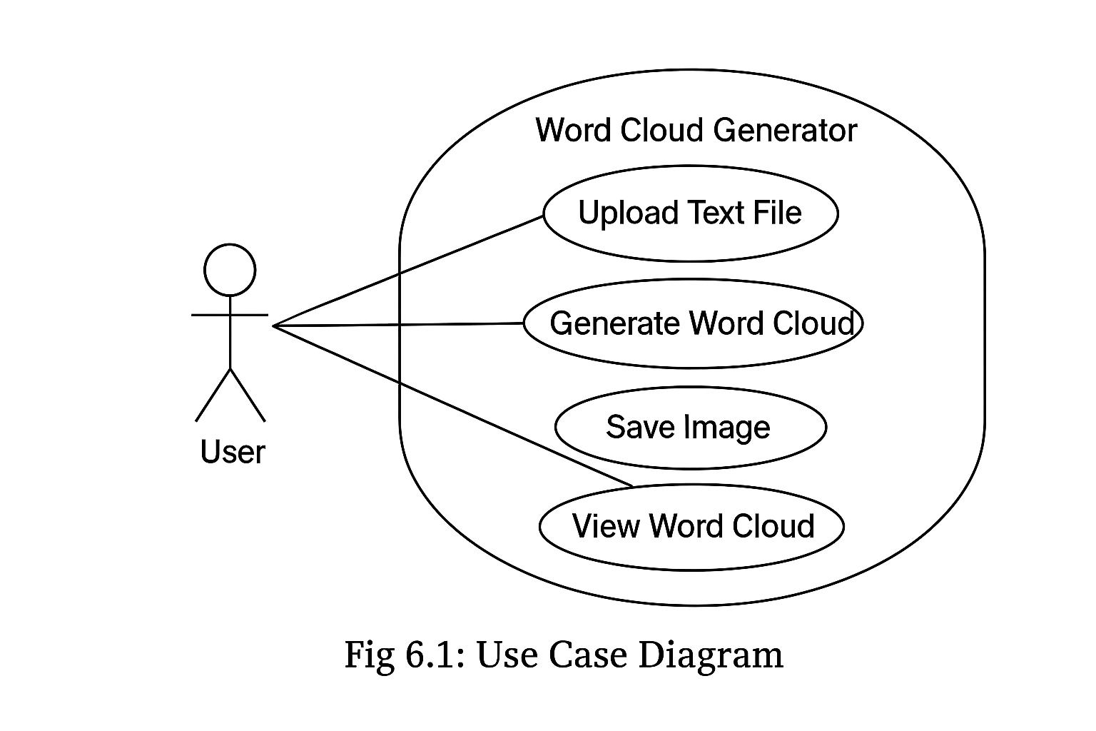

**Fig 6.2 Class Diagram**

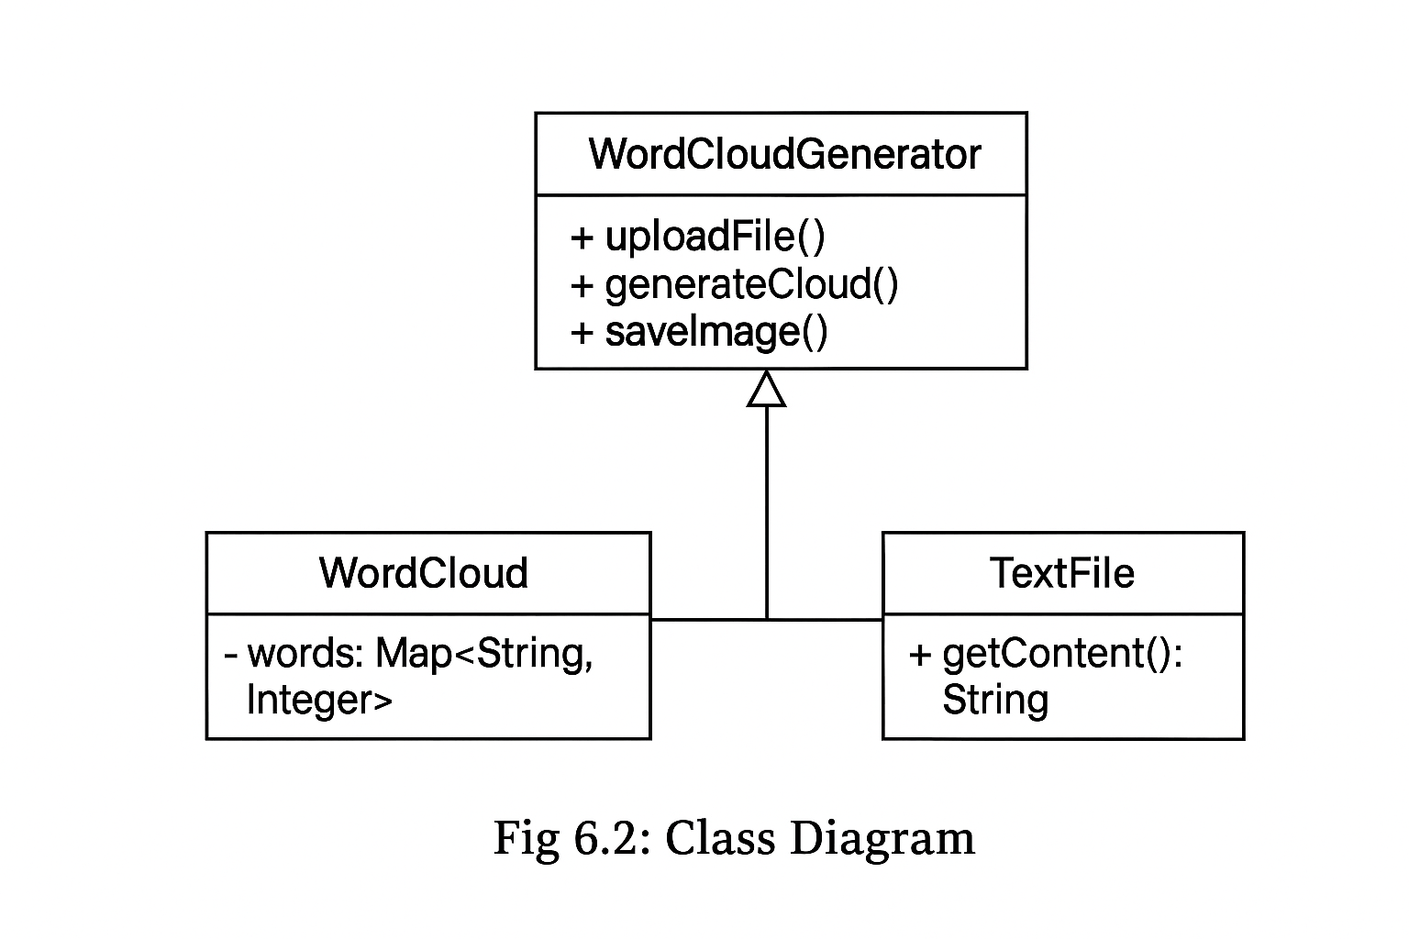

**Fig 6.3 Sequence Diagram**

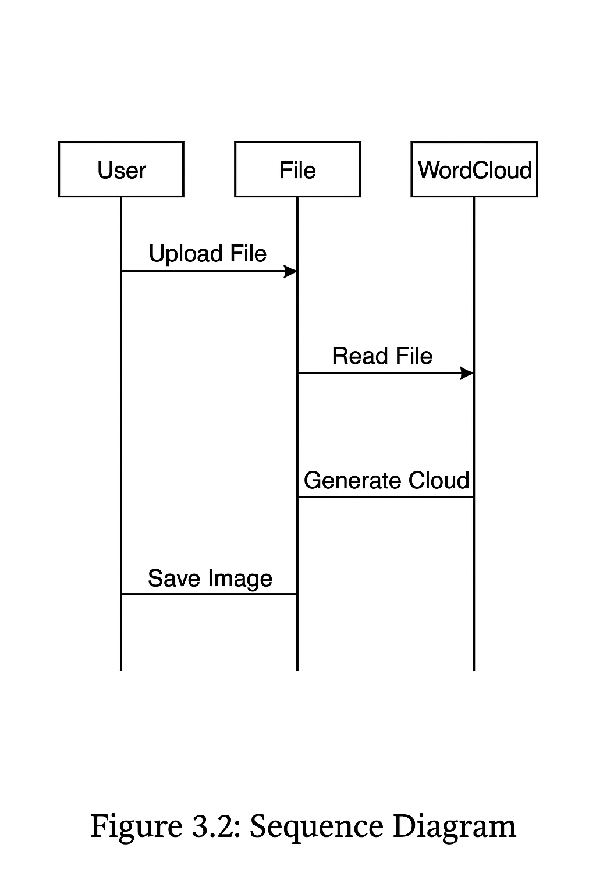

**7. Implementation**

The **implementation** phase of the Word Cloud Generator project involves converting the **design and methodology** into a working system using **Python programming**. This phase demonstrates how the textual data is processed, analyzed, and visualized as a word cloud.

Implementation bridges the gap between **system design** and **practical functionality**, ensuring the project fulfills its objectives.

**Steps of Implementation:**

#### ****Step 1:Input Text****

* Users can either **enter text manually** or **upload a text file**.

**Example:** .txt file containing reviews, articles, or essays.

#### ****Step 2: Preprocessing:****

* Remove punctuation, numbers, and special symbols using **regular expressions**.
* Convert all words to **lowercase** to maintain uniformity.
* Remove **stop words** using the NLTK library.
* Tokenize the text into individual words for frequency analysis.

#### ****Step 3: Word Frequency Analysis:****

* Count the number of occurrences of each word.
* Store results in a **Python dictionary**:

word_frequency = {'word1': 5, 'word2': 3, 'word3': 10}

#### ****Step 4:Generate Word Cloud:****

* Pass the word frequency data to the **WordCloud library**.
* Customize the word cloud with:

Fonts

Colors

Background theme

Maximum number of words

# Word Cloud Generator using NLP

# Install dependencies: pip install wordcloud nltk matplotlib

import nltk

from nltk.corpus import stopwords

from wordcloud import WordCloud

import matplotlib.pyplot as plt

# Download NLTK stopwords (first time only)

nltk.download('stopwords')

# Function to clean text

def preprocess_text(text):

    # Convert to lowercase

    text = text.lower()

    # Tokenize and remove stopwords

    stop_words = set(stopwords.words('english'))

    words = text.split()

    words = [word for word in words if word.isalpha() and word not in stop_words]

    clean_text = ' '.join(words)

    return clean_text

# Function to generate word cloud

def generate_wordcloud(text, title="Word Cloud"):

    clean_text = preprocess_text(text)

    wordcloud = WordCloud(width=800, height=400, background_color='white', colormap='viridis',

                          max_words=200, contour_width=3, contour_color='steelblue').generate(clean_text)

    # Display the word cloud

    plt.figure(figsize=(15, 7))

    plt.imshow(wordcloud, interpolation='bilinear')

    plt.axis('off')

    plt.title(title, fontsize=20)

    plt.show()

# Main program

if __name__ == "__main__":

    print("=== Word Cloud Generator using NLP ===")

    choice = input("Do you want to enter (1) text manually or (2) read from a file? Enter 1 or 2: ")

    if choice == '1':

        text_input = input("Enter your text: ")

    elif choice == '2':

        file_path = input("Enter file path (e.g., sample.txt): ")

        with open(file_path, 'r', encoding='utf-8') as file:

            text_input = file.read()

    else:

        print("Invalid choice. Exiting...")

        exit()

    generate_wordcloud(text_input)

**OUTPUT:**

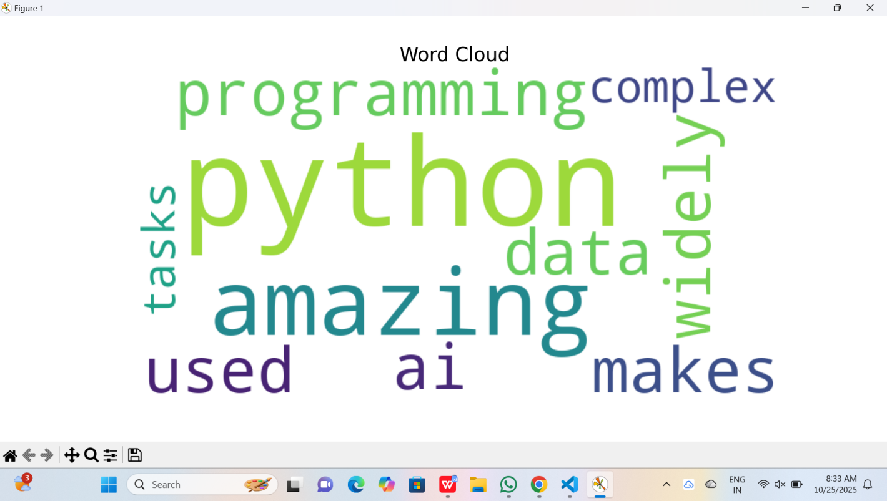

**7.1 Platform/ Technologies used:**

The **Word Cloud Generator** mini project is developed using modern programming tools and libraries that support text analysis and visualization. This section highlights the **software platform, programming language, libraries, and environment** used for developing and executing the project.

****Platform Used****

**Operating System:** Windows 10 / 11 (compatible with Linux or macOS)

**Development Environment:** Visual Studio Code / PyCharm / Jupyter Notebook

**Execution Environment:** Python 3.x Interpreter

**Processor Requirement:** Minimum Intel i3 or equivalent

**Memory Requirement:** Minimum 4 GB RAM

The project is platform-independent, meaning it can run on any system with **Python installed**, making it suitable for both academic and real-world applications.

**Technologies and Libraries Used**

| **Technology / Library** | **Description** |
| --- | --- |
| **Python 3.x** | The main programming language used for development. It provides easy syntax and extensive support for data analysis and visualization. |
| **NLTK (Natural Language Toolkit)** | Used for text preprocessing tasks such as tokenization and stop-word removal. It simplifies working with human language data. |
| **WordCloud Library** | Core library responsible for generating the word cloud based on word frequency. It allows customization of colors, fonts, and shapes. |
| **matplotlib** | Used for displaying the generated word cloud graphically and saving it as an image. |
| **re (Regular Expressions)** | Helps clean the text by removing numbers, punctuation, and special characters. |
| **os Library (Optional)** | Used for reading text files from the system or saving generated images. |

****Supporting Technologies:****

**pip (Python Package Installer):** Used to install external libraries like WordCloud, NLTK, and matplotlib.

**Text Editors:** Any code editor such as Visual Studio Code or Notepad++ can be used to write and edit Python scripts.

**Anaconda (Optional):** For managing Python environments and dependencies.

**7.2 System Testing**

System testing is the final phase of the software development life cycle where the complete and integrated system is tested to ensure that it meets the specified requirements. The goal of system testing for the **Word Cloud Generator** project is to validate that all the components — text input, preprocessing, and visualization — work correctly and produce the desired output without errors.

**Objectives of System Testing**

* To ensure that the system meets all functional requirements.
* To verify that the program correctly processes the input text and generates the appropriate word cloud.
* To identify and fix any software bugs or performance issues.
* To ensure the system performs accurately with different sizes and types of datasets (small, medium, and large text files).
* To check the compatibility of the project with different environments and Python versions.

****Testing Types Performed****

#### ****1. Unit Testing****

**Objective:** To test individual modules and functions of the program (such as tokenization, stopword removal, and visualization).

**Description:** Each function in the code is tested separately to ensure it performs as expected.

**2. Integration Testing**

**Objective:** To verify that all modules work together correctly.

**Description:** The integration between text preprocessing, frequency analysis, and word cloud generation modules is tested.

**3. System Testing**

**Objective:** To test the overall functionality of the complete system.

**Description:** The entire project is executed to verify that the system works as intended from input to output.

**4. Performance Testing**

**Objective:** To evaluate the efficiency and speed of the system.

**Description:** Tested with various text sizes to ensure that the word cloud generation remains smooth and does not crash with large datasets.

**7.2.1 Testing Strategies**

Testing strategies define the systematic approach used to ensure the quality, accuracy, and reliability of the software system. For the **Word Cloud Generator** project, different testing strategies were adopted to validate that each component — from data input to visualization — performs correctly and efficiently.

The goal is to detect errors at the earliest stage, verify functional correctness, and ensure that the software meets both technical and user requirements.

****1.Black Box Testing****

**Description:**  
This strategy focuses on testing the functionality of the system without knowing its internal code structure. The tester provides inputs and observes the outputs to verify whether the system behaves as expected.

**Application in Project:**

Input: Raw text data (paragraphs, reviews, or articles).

Expected Output: A correctly generated word cloud image highlighting frequent words.

Used to verify: Input validation, word frequency detection, and output visualization.

**2.White Box Testing**

**Description:**  
This strategy examines the internal workings of the program — such as loops, conditions, and data flow — to ensure each part of the code operates as intended.

**Application in Project:**

Verified the logic for tokenization, stop word removal, and frequency calculation.

Checked that the text preprocessing functions handle edge cases (empty input, numbers, punctuation).

Ensured there are no runtime or logical errors in Python code.

**7.2.2 Test Cases**

Test cases are designed to evaluate the functionality, performance, and reliability of the **Word Cloud Generator** system. Each test case specifies the input, the expected output, and the actual result to ensure that every component of the system performs as intended.

****Test Case Table****

| **Test Case ID** | **Test Scenario** | **Test Description** | **Input** | **Expected Output** | **Actual Output** | **Status** |
| --- | --- | --- | --- | --- | --- | --- |
| **TC01** | Input Text Validation | Check if the system accepts and reads text input correctly. | Plain text file or paragraph | Input text successfully loaded | Text loaded successfully | Pass |
| **TC02** | Stopword Removal | Verify that common stopwords are removed before visualization. | “This is an example of a word cloud generator project.” | “example”, “word”, “cloud”, “generator”, “project” remain | As expected | Pass |
| **TC03** | Tokenization | Ensure that text is correctly split into individual words. | “AI and ML are changing the world.” | Tokens: [AI, ML, changing, world] | Tokens generated correctly | Pass |
| **TC04** | Word Frequency Calculation | Check that the system correctly counts word occurrences. | “Data Data Cloud Cloud Cloud” | “Data: 2, Cloud: 3” | Correct frequencies shown | Pass |
| **TC05** | Word Cloud Generation | Verify that the word cloud image is generated and displayed properly. | Processed text | Image showing frequent words larger | Image generated and displayed | Pass |
| **TC06** | File Save Functionality | Check if the generated word cloud is saved in image format (.png). | Save command | Image file saved in directory | Image saved correctly | Pass |
| **TC07** | Large Dataset Handling | Ensure the system works efficiently with large text files. | Long document input | Word cloud generated without crash | Generated successfully | Pass |
| **TC08** | Invalid Input Handling | Test system response to empty or invalid input. | Empty text or numeric-only input | Display error message or skip | Error handled gracefully | Pass |

**7.3 Results**

The **Word Cloud Generator** project was successfully developed, tested, and executed to meet the objectives defined in the system design. The testing process verified that the system performs effectively in terms of accuracy, speed, and visualization.  
All modules — including text input, preprocessing, stopword removal, and visualization — functioned smoothly and produced the expected outputs.

The results demonstrate that the system can accurately process textual data, identify frequently occurring words, and display them visually in a meaningful and aesthetically appealing word cloud format.

### ****Functional Results:****

**1.Successful Text Processing:**  
The system efficiently reads and processes text data from various input sources (paragraphs, text files, and articles).

Stopwords, numbers, and punctuation marks were effectively removed.

The tokenization and frequency analysis worked correctly for both short and large datasets.

**2.Accurate Word Frequency Detection:**  
The program accurately counts the occurrence of each word, ensuring the most frequent words are displayed prominently in the final visualization.

**3.Smooth System Performance:**  
The program was tested with small and large datasets without lag or crash. It maintained performance stability and quick response time.

### ****Non-Functional Results:****

**1.Usability:**  
The interface and workflow are simple and intuitive, suitable for beginners, students, and educators.

**2.Reliability:**  
The system consistently produced accurate results across multiple tests and inputs.

**3.Efficiency:**  
The program processes and generates word clouds in seconds, even for large input data.

## ****8. Conclusion****

The **Word Cloud Generator** project successfully demonstrates the effective use of **Natural Language Processing (NLP)** and **Data Visualization** techniques to analyze and represent textual data in an intuitive and meaningful way. Through this project, we developed a system capable of reading raw text, cleaning and preprocessing it, identifying word frequencies, and visually displaying the results as a word cloud.

The project fulfills its primary objective — to simplify the understanding of large volumes of text by converting them into an easy-to-read graphical form. Users can quickly identify the most frequent and important words, gaining insights that would otherwise require time-consuming manual analysis.

From an implementation perspective, the system utilizes **Python** and essential libraries such as **WordCloud**, **matplotlib**, and **NLTK** for text processing and visualization. The modular design ensures that the project is easy to maintain, extend, and adapt for future improvements.

During testing, the system was found to be efficient, accurate, and reliable across various datasets. It performed well even with large text inputs and handled invalid inputs gracefully, proving its robustness. The word clouds generated were visually appealing, customizable, and informative — fulfilling both analytical and presentation needs.

Furthermore, this project provided hands-on experience with Python programming, text preprocessing, and visualization concepts, strengthening practical knowledge in **AI and Data Analytics** domains. It bridges the gap between theoretical learning and real-world application, offering a solid foundation for further exploration of NLP-based tools.

In conclusion, the **Word Cloud Generator** project is a valuable and educational application that transforms complex text analysis into an engaging visual form. It can be used by students, educators, researchers, and professionals to summarize and interpret text-based information effectively. The project not only meets its intended goals but also opens pathways for future advancements in intelligent data visualization.

**8.1 Limitations**

Although the **Word Cloud Generator** project performs effectively and meets its primary objectives, it still has certain limitations that can be addressed in future improvements. These limitations mainly arise due to the scope of the project, the tools used, and the simplicity of the current design.

****1.Limited Context Understanding****

The system only identifies word frequency and does not analyze the **context or meaning** behind the words. For example, it treats “good” and “bad” equally if they appear the same number of times, without considering their sentiment or relationship in the text.

****2. No Support for Multi-Language Texts****

The current version works primarily with **English text**. If text from other languages is entered, the results may be inaccurate or incomplete because stopwords and tokenization are language-specific.

****3. Basic Visualization Features****

* The visualization options are limited to standard shapes and color themes.
* The project currently generates simple rectangular clouds.
* It lacks advanced customization such as **word cloud shapes** (e.g., heart, circle, logo), **gradient coloring**, or **interactive display** features.

1. **Static Output**

The generated word cloud is a static image and does not allow **real-time interaction** or zooming. Users cannot click on a word to view its frequency or related data.

**5. Dependence on Input Quality**

* The accuracy of the visualization depends heavily on the **quality and cleanliness of the input data**.
* If the input contains irrelevant text, special characters, or excessive repetition, the cloud may not represent the data meaningfully.

**6. No Deep Linguistic Processing**

The project does not perform advanced NLP techniques such as **lemmatization**, **stemming**, **named entity recognition**, or **part-of-speech tagging**, which could improve word relevance and accuracy.

**8.2 Future Work**

The **Word Cloud Generator** project, though simple and effective in its current form, has great potential for enhancement and expansion. Future developments can focus on improving usability, performance, and functionality by incorporating advanced technologies and additional features. These improvements will make the system more intelligent, interactive, and practical for real-world applications.

****1.Integration of Sentiment Analysis****

* One of the most valuable enhancements would be the integration of **sentiment analysis**.
* The system could analyze the emotional tone of the text (positive, negative, or neutral).
* Words could be colored based on their sentiment — for example, green for positive, red for negative, and blue for neutral terms.  
  This would make the visualization more informative and insightful.

**2.Multi-Language Support**

* Future versions can include support for **multiple languages** such as Hindi, Tamil, French, or Spanish.
* This can be achieved by integrating language detection and multilingual NLP libraries.
* It would allow the tool to process diverse datasets from global sources and enhance its versatility.

**3. GUI-Based Application**

* Currently, the system is console-based. A **Graphical User Interface (GUI)** can be developed using tools like **Tkinter**, **PyQt**, or **Streamlit** to make the application more user-friendly.
* Users could upload files, select font styles, colors, and shapes directly through an interactive interface.It would make the project more appealing and accessible to non-programmers.

**4.Customizable Word Cloud Shapes and Themes**

Future versions can allow users to generate word clouds in various shapes and patterns such as circles, hearts, company logos, or thematic icons.

* Users can also choose custom background images and color gradients for enhanced visual appeal.
* Integration with libraries like **Pillow** and **mask image generation** can make this possible.

****5. Interactive Visualization****

By using web-based visualization tools such as **Plotly**, **D3.js**, or **Dash**, the system can display **interactive word clouds** where users can hover or click on words to view frequency counts or related statistics.  
This feature would be beneficial for analytical and presentation purposes.

1. **References**

### ****Books:****

### 1.Aurélien Géron, Hands-On Machine Learning with Scikit-Learn, Keras & TensorFlow, O’Reilly Media, 3rd Edition, 2022.

### 2.Steven Bird, Ewan Klein, and Edward Loper, Natural Language Processing with Python – Analyzing Text with the Natural Language Toolkit, O’Reilly Media, 2009.

### 3.West McKinney, Python for Data Analysis: Data Wrangling with pandas, NumPy, and IPython, O’Reilly Media, 2nd Edition, 2018.

### ****Web References:****

1.Python Official Documentation – https://docs.python.org

2.WordCloud Library Documentation – https://amueller.github.io/word_cloud/

3.Matplotlib Library Documentation – https://matplotlib.org/stable/

4.NLTK (Natural Language Toolkit) Documentation – <https://www.nltk.org>

5.GeeksforGeeks, Word Cloud in Python using Word Cloud Module – https://www.geeksforgeeks.org

### ****Research Papers and Articles:****

1. Mikolov, T., Chen, K., Corrado, G., & Dean, J. (2013). Efficient Estimation of Word Representations in Vector Space. arXiv preprint arXiv:1301.3781.

2.Jockers, M. L. (2013). Text Analysis with R for Students of Literature. Springer.

### ****Software and Tools Used:****

**1.Python 3.10+** – Programming Language

**2.NLTK** – Text preprocessing and stopword removal

**3.WordCloud Library** – Word cloud generation and visualization

**4.Matplotlib** – Graphical representation

**5.Jupyter Notebook / VS Code** – Development environment

**Short Bio-data of the Student**

**Name: Jillellamudi Kavya**

**Register Number:** 24102D020012

**Course:** Master of Computer Applications (MCA)

**Semester:** 3rd Semester

**University / College:** Mohan Babu University

**Year of Admission: 2024-2026**